Argentina & Canada Unite as One !!!  ARCAN Institute are pleased to invite  you to attend our classes for an  incredible Taekwon-Do and fun- filled  fitness experience!!! Classes are instructed by  Mr. Diego Cabanas a certified 4th  Degree black belt under the  International Taekwon-Do Federation.  Mr. Cabanas started I.T.F. Taekwon-Do  In Argentina in 1993, and has not only  represented Argentina several times  as an athlete at the I.T.F. World  Championships, he was a coach for the  Canadian National Team!!!!!! Mr. Cabanas  moved to Canada to spread his ample  knowledge in I.T.F Taekwon-Do, as Argentina  has one of the largest followings in Taekwon-  Do in the WORLD!!! Mrs. Alana Thibodeau-  Cabanas is a certified 3rd degree black belt  with the I.T.F. and she began practicing  Taekwon-Do in 1998. Mrs. Thibodeau-  Cabanas represented Canada as a member of  the Canadian National Team several times  and recently won a Gold medal at the I.T.F.  World Championships in St. Petersburg,  Russia. Both Mr. And Mrs. Cabanas are  dedicated Instructors and continually strive  to ensure the teachings of I.T.F Taekwon-Do  remain pure as the founder General Choi  created it. Come check out their dynamic  energy filled classes for a true, original  Taekwon-Do adventure!!!!!  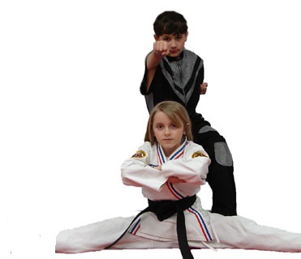  Youth Classes!!!!  ARCAN Institute realizes the issues youths  face in today’s society. Struggles with  bullying, peer-pressure, self-confidence and  respect. ARCAN Institute Instructors have  been teaching youths for many years and  know the importance of values and morals.  The Instructors realize it is their job to ensure  high quality instruction in Taekwon-Do to  create a positive atmosphere for the youths  to reach their utmost potential. Benefits  that parents can see right away from their  children practicing Taekwon-Do are:  - Improved FOCUS and Leadership Qualities & Abilities  - SELF-CONFIDENCE  - Self-Discipline and Self Respect  - Respect for others  - Improved health & fitness  - Better muscular strength, co-ordination & development  As the students progress through the ranks  or belts of Taekwon-Do, parents can see  their children setting goals and achieving  those goals. The youths learn their hard work  is rewarded in a positive way as they are one  step closer to that coveted BLACK BELT!!! | 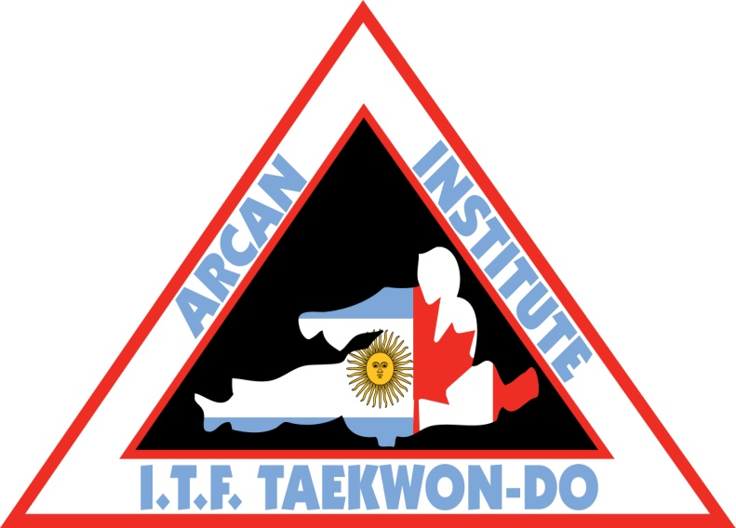  ARCAN Institute  I.T.F Taekwon-Do  Grant Public School  2625 Draper Ave Nepean  Pierre Elliott Trudeau Catholic School  601 Longfields Drive Barrhaven  St. Gregory Catholic School  148 Meadowlands Drive Nepean  CALL 613-226-4374  Or email arcantkd@hotmail.com  For registration info  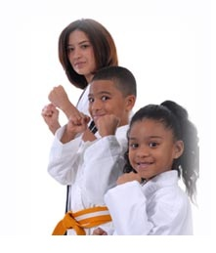  Teens/Adult & Family Classes  ARCAN Institute is pleased to offer a dynamic, energetic atmosphere for teens and adults to train in. Fitness is becoming a national and international priority as health issues continue to rise. Teens are now facing much more stress than in the past and require a positive atmosphere to channel their energy. A healthy body creates a healthy mind, and a healthy mind contributes to a better society.  No one is too old to start Taekwon-Do. Taekwon-do offers more than physical fitness. It has deep moral teaching and culture and becomes a way of life. The entire principal behind Taekwon-Do is to promote a better society and a more peaceful world. ARCAN Institute is proud to offer classes where teens and adults can train together and reap the following benefits:  - Better muscular strength & endurance  - Reduce stress  - Improved flexibility & cardiovascular fitness  - More self-confidence, focus & concentration  - Positive goal setting & a sense of achievement  ARCAN Institute offers family classes and family rates. Family training creates a positive commonality among a family and strengthens the bonds between child and parent. Having this activity in common allows for families to practice together outside of class, attend Taekwon-Do functions together such as tournaments, BBQ’s and other social events. With today’s society being so busy, it’s important to find a family activity to bring everyone together!! | 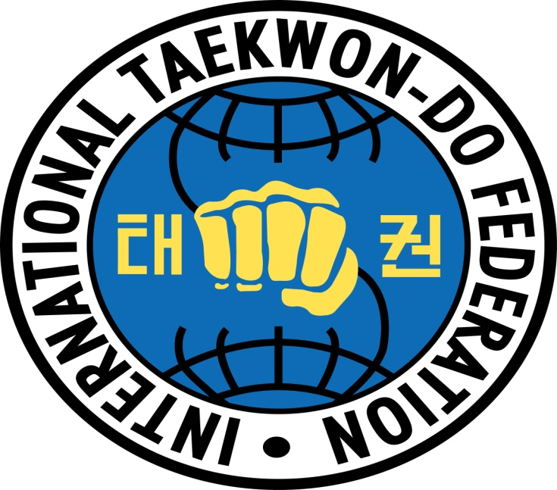  ARCAN Institute  I.T.F Taekwon-Do  NEW SCHOOLS NEW LOCATIONS!!  Train at 3 locations, train up to 5 days a week at  NO EXTRA COST!!!  SPECIAL PRICE $49.99  includes 1 month of training &  FREE UNIFORM!!!!!!  Instructors from ARGENTINA and CANADA!!!  For more info contact us at 613-226-4374  Or email at arcantkd@hotmail.com  Affiliations  ARCAN Institute has strong affiliations to National and International governing bodies, and these ties sets this school apart from others. ARCAN Institute is honoured to be affiliated with the International Taekwon-Do Federation. This federation is recognized & represented in every country around the world. The I.T.F provides practitioners with proper, recognized certification for belt ranks. The I.T.F is responsible for International seminars to ensure that all instructors around the world are teaching Taekwon-Do properly and purely as the founder would have wanted it. ARCAN Institute Instructors attend these seminars regularly to ensure instruction is always proper and up to date. Website for more info www.tkd-itf.org  ARCAN Institute is affiliated nationally with the Canadian Taekwon-Do Federation International (C.T.F.I). The national body allows ARCAN Institute athletes to attend all provincial, regional and national tournaments and the chance for selection to represent Canada at the I.T.F. World Championships. Website for more info is www.ctfi.org  Membership Entitlements  Upon becoming a proud member of the ARCAN Institute all students will receive:  - Their own student manual  - A special testing manual for all belt tests  - Free belts with each testing  - Provincial, National and International Competitions  - Proper, recognized certification from the CTFI & ITF headquarters  - Special seminars with instructors from all over the world!!  - Top quality instruction from certified instructors and coaches that have national and international recognition!!  I.T.F Taekwon-Do is practiced in every country around the world and the most practitioners of any martial art that exists today!!!!!!!!!!!!

