Dear Masters and instructors
It is a great pleasure to invite you to the First Time in Canada, The International Harmony Program as designed by GM Trajtenberg, President of the ITF.
This IHC will be held in Moncton, NB, Nov. 4 – 5, 2017. The venue for the event will be te Crowne Plaza Moncton Downtown.
We are looking forward to seeing you and your students in Nov.
Yours in TaeKwon-Do
Jim Ripley V Dan
International Instructor/Examiner
JC’s TaeKwon-Do

1.1: Introduction to Harmony Program

THE HARMONY PROGRAM
The Harmony Program is a new program that will be launched in 2015 by the ITF. This exciting new initiative will be based on integrating those aged 50 and older into ITF TaeKwon-Do by adapting the ITF syllabus to suit those who wish to start training in later life. It will attract a new age group to our wonderful art by catering to their needs in a more harmonizing way.

At present, the life of a man or woman is prolonged much more than a few years ago, mainly due to the exercise and the advancement of medicine.
However, many of these senior people do not find any exercise which results attractive to them, which is why they feel marginalized and not taken into account. But they are wrong; here comes a wonderful tool to enjoy Taekwon-Do, particularly if one is an older adult.
From now on, then, within the teaching of Taekwondo ITF, older adults constitute a “specialty” that transforms us into the first martial art with a specific program for those ages.
Our program is specifically adapted for people with advanced ages who want to work their bodies and minds with a special body care.
This program has as aim that the practitioner improves their quality of life, from the physical and social aspects through the practice of Taekwon-Do.
The exercises in this program are designed to work the qualities that need to be strengthening in these ages within a framework of security, which will provide the practitioner physical independence and self-confidence.
The ITF introduces this program in order to include all the age bands of the society, providing our seniors an opportunity to do an activity in a pleasurable way with countless associated benefits.
This is from the ITF website.

2.1: Place and Time
The International Harmony Course will take place Nov. 4 – 5, 2017in the Crowne Plaza Moncton Downtown located at 1005 Main St., Moncton, NB, E1C1G9 Phone 1-506-854-6340, Fax 1-506-857-4176, website www.cpmoncton.com

We have secured a special rate of $129 per night for Single, Double, Triple or Quad occupancy.
Standard room with 1 or 2 Queen beds
Free parking and WIFI included.
Reservation Procedure:
To make reservations with the special rate, the participant just needs to mention they will be coming for the ITF TaeKwon-Do seminar or mention the block code EGF. The cutoff date for this rate will be Oct. 10, 2017
Telephone: 1-866854-4656 or 1-506-854-6340
Email: reservations@cpmoncton.com
Check –in time is 3pm and check-out is at 11am

3.1 Details of instructors and Organization
Promoter
International TaeKwon-Do
www.tkd-itf.org
Organizer
JC’s TaeKwon-Do
Amherst, NS
Jcstaekwondo.com

Course Instructor
Mr. Gaston Casero V Dan
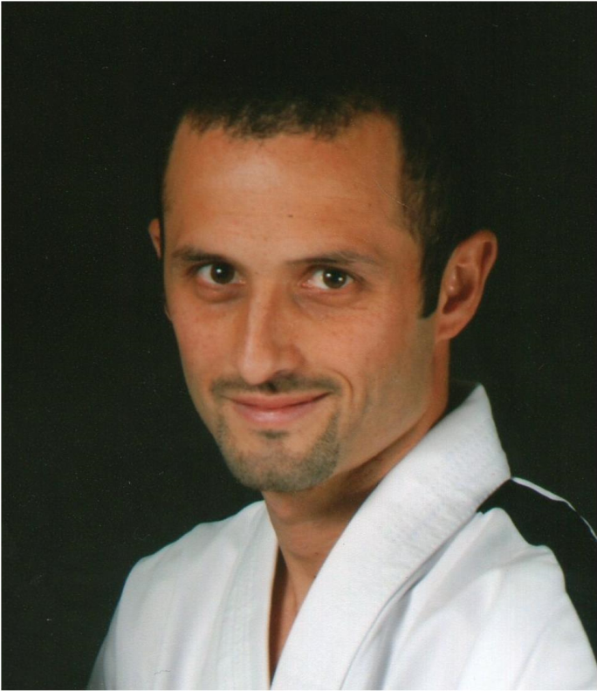
Gastón Casero
He has been Professor of Physical Education in Argentina since 1999
With 40 years is 5 Dan, direct student of GM Pablo Trajtenberg.
He has competed nationally and internationally on several occasions.
He has a Sports Services company that is currently developing in closed neighborhoods of the northern zone of Buenos Aries.
He was in charge of the AFyS program (physical activity and health) developed in Buenos Aires and Malaga (Spain), aimed at adults and seniors.
When some time ago the GM Pablo Trajtenberg created the program, and proposed to develop it together, took the opportunity to dump there his intense years of work with adults and adults.
With a double motivation: on the one hand, thinking that that age is a moment of life to which we all will arrive. And on the other hand, according to Gastón, "... working with these ages is to give back to the elderly the repetition that our instructors taught us by doing a special program for them where they can feel at ease in various aspects, providing well-being"

Special Guest
GM Trajtenberg
President of the International TaeKwon-Do Federation
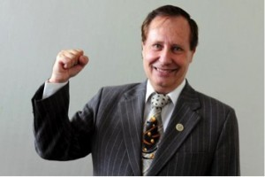
Grandmaster Trajtenberg
Grand Master Pablo Trajtenberg took up his Taekwon-Do practice in 1968, while seeking to learn Karate. He found the class he liked most and as he watched he said to himself: “I shall become a black belt, no matter what it takes“. One week later he was given his enrollment card and thought there must be some mistake as it read “Taekwon-Do”, but when he told the secretary he was informed that this was Korean Karate, the best!. From that moment on his practice has been non-stop.
His Teacher was Nam Sung Choi, one of the Taekwon-Do pioneers in Argentina, who had arrived one year earlier, in 1967. This master left cherished memories and profound gratitude is owed to him for the passion he transmitted class after class.
Then came Grandmaster Trajtenbergs first meeting with General Choi Hong Hi during his early journeys to Argentina, where he became mesmerized by his personality, thus turning into an ardent Taekwon-Do student. He obtained his black belt degree in 1971, although back in those times certificates took a long time to arrive and it was not polite to point this out to the Master. His enthusiasm then lead him to tuition, a successful endeavor judging from the many students who attend his courses.
In 1973, together with a fellow student, he hosted a luncheon at the Sheraton hotel to honor the General on one of his trips and was given a photograph with the following dedication “To a serious Taekwon-Do student, with my best wishes”.
These were the years of division within Taekwon-Do and Master Nam Sung Choi was compelled to join WTF, which led Trajtenberg to a painful choice that separated him from his Master and it is so that in 1978 he began corresponding with some Argentine black belts and the General supported this move, which consolidated with the arrival of pioneer Master Jon Chang Kim as a delegate to promote Taekwon-Do in Argentina.
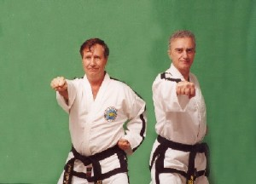
In 1977 Trajtenberg gave up his university studies for good, only one year short from graduating as an electronic engineer, with the goal of devoting himself full-time to the teaching of Taekwon-Do, his overruling passion, and in 1980 he opened the “Centro Argentino de Taekwon-Do”, which would become a classic, together with Héctor Marano, his fellow and friend since White Belt times.
In 1981 he actively collaborated with the organization of the World Championship held in Argentina, headed by World Champion Javier Dacak, a dear friend, and he became closer to General Choi Hong Hi when he travelled to visit him and train under him. The General generously lodged him at his daughter Sunny´s home and thus he gained access to the very source. This was a difficult sort of journey but the General´s teaching vocation always reserved room for those genuinely interested in learning, as his case was.
There was a difficult time upon General Choi´s visit Argentina as there was a military dictatorship and the Korean embassy accused ITF of being communist sympathizers, which forced Trajtenberg to shelter General Choi in his own home for protection, while transferring his family elsewhere.
During these years Trajtenberg visited Master J.C. Kim and also Si Ki Choi, Park Jong Soo and other great masters.
His main students were formed during this period, who are at present 7th and 8th Dans, several of them with international stature. Consequently Argentinean Taekwon-Do developed in parallel with its participation in World tournaments and global activities.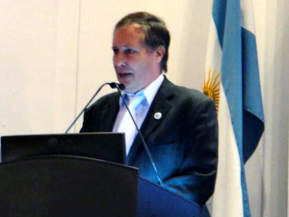
While attending ITF´s first IIC in Vienna as the Argentinean delegate he obtained support for his country, which in 1986 permitted the foundation of the Taekwon-Do Federation for the Argentine Republic – thus gaining autonomy from Korean predominance, and in this institution he has acted as Secretary General to this day.
He travelled abroad to introduce Taekwon-Do to Bolivia, Brazil and Uruguay; Brazil being the country where he was faced with the biggest obstacles to expand Taekwon-Do. A lasting friendship was born between Trajtenberg and Tran Trieu Quan while sharing countless experiences impossible to summarize herein. He also developed a great friendship with Wim Bos and with Clint Norman, all of them brethren united by their common passion.

In 1993 he concluded an intense task in collaboration, namely the translation of the condensed Encyclopedia into Spanish, following the guidelines and corrections from Taekwon-Do´s Founder.
In 1994 he was bestowed, in Malaysia, with one of the most important awards that the General conferred to only 9 of his Western disciples, the “Prize for Loyalty”, which he regards proudly as one of his top achievements.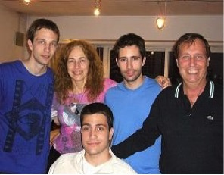
Together with Tran Trieu Quan he actively participated as ITF delegate, therefore occupying a position of great responsibility upon the General´s death.
The rest is recent history and it may be claimed that he is now a happy man as President of ITF, always surrounded by good friends, Great Masters and Instructors and above all proud of his students, many of whom have become Masters. His closest circle is made up by Sonia and Vivian, his two sisters, and a wonderful wife: Liliana Ferreiro, with whom he has shared his life for 35 years and who has given him three sons: Alejandro, Luciano and Kevin. As he himself likes to point out, there is nothing else he can ask from life.
Courtesy of the ITF website
4.1 Application and Contact:
Email: Jim Ripley
jripley@jcstaekwondo.com
Phone: 1-902-667-5425
Arrival by air at Moncton International Airport on Nov.3, 2017
By vehicle at the Crowne Plaza Moncton Downtown, 1005 Main St., Moncton, NB, E1C1G9

5.1: Course Fees:
2nd kup – 6th Dan $150.00US
7 & 8 Dan $70.00US
9 Dan Nil
Registration form is attached on last page.
Payments can be sent by E-transfer to jripley@jcstaekwondo.com
US money order may be mailed to Jim Ripley, 224 Ripley Rd., Truemanville, NS, B4H 3Y2
Money orders payable to JC’sTaeKwon-Do
6.1 Insurance
The Organizing Committee for the IHC Moncton will NOT be responsible for any possible injuries caused during this seminar. All particapants must have full insurance coverage by their own organization.
7.1: Schedule of events
Nov. 3, 2017, Check in at venue 6 – 8pm
Nov. 4, 2017 Final Check in 7 – 8am
Harmony course 9am – 12pm (Mr. Gaston Casero)
Lunch 12 – 2pm (back in venue lined up for 2pm)
Training 2 – 5pm with GM Trajtenberg
Nov.5, 2017 Harmony course 9 – 11am (Mr. Gaston Casero)
11am – 12pmQuestion period, closing of IHC & Photos opportunity

8.1: Registration Form
See attached form

