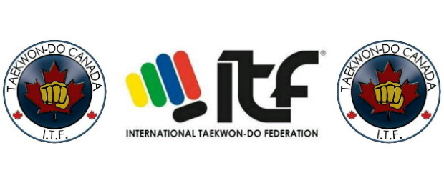
WC2015 CTFI Strategic Timeline: Team Coach, Team Manager
Coach Selection Advisory Panel: CTFI President, Technical Director, Tournament Director, Umpire Director
Team Manager Selection Advisory Panel: CTFI Executive Vice President, Vice President West, Vice President East
11 Months prior to the World Championships: July 2014
- Coach selection: calls for applications for the Team Canada Coach.
- Team Manager selection: calls for application for Team Canada Manger.
11 Months prior to the World Championship: July 2014
- Close for Coach/Manager applications.
10 Months prior to the World Championship: August 2014
- Select CTFI Team Coach
- Select CTFI Team Manger
- Announce selections on the CTFI website
9 months prior to the World Championship: September 2014
- Head Coach selects Assistant Coach(s) (CTFI Board of Directors reserves the right of veto)
- Head Manager selects Assistant Manager(s) (CTFI Board of Directors reserves the right of veto) Coaching and Management Team develop and schedule future squad trainings in consultation with the CTFI Board of Directors.
7 months prior to the World Championship: October 2014
- Team training schedule following CTFI nationals posted on website.
- Team manager finalizes team travel agent (and flight cost if possible), hotel accommodation, airport to hotel shuttle (and cost). Hotel selection and travel agent must be approved by the CTFI Board.
- Team manager finalizes track suit and uniform design and price.
6 Months prior to the World Championship: November 2014
- CTFI National Championship. Team selection. Selected team members provide a 100.00 commitment deposit. All team members to receive a brief outlining responsibilities and financial commitment for upcoming World Championship
- Team pictures taken for competition ID cards. Backdrop for ID card picture is the Canadian flag.
- All competitors must wear dobok for picture.
- Official confirmation letter authorized by CTFI president provided to team members.
5 - 1 Months prior to the World Championship Team training
- Team training.
6 - 1 Months prior to the World Championship Team management
- 6 months prior- during the National Championship all competitors selected for the Canadian team will receive a written brief outlining projected costs, time commitments etc ( see above)
- 5 months prior - all uniforms and doboks ordered and paid for.
- 5 months prior - flights booked with deposit or full payment ( if required)
- 4 months prior - hotel rooms booked with deposit or full payment ( if required)
- 4 months prior- flights paid for.
- 3 months prior - hotel rooms paid for.
- 1 month (4 weeks) prior - all uniforms and doboks delivered to delegation members.

